AAS Annual Beds:
Learn more about AAS (All America Selection) and AAS varieties here: http://all-americaselections.org/winners/
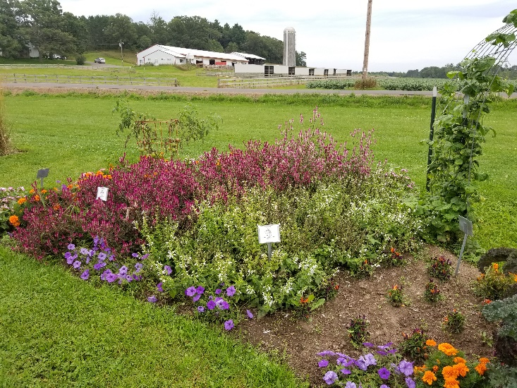
Bed 1:
Celosia; Asian Garden AAS 2017
Bean; Potomac
Petunia; Evening Scentsation AAS 2017
Ornamental Pepper; Numex Easter AAS 2014
Salvia; Summer Jewel White AAS 2015
Tomato; Chef’s Choice Green AAS 2016
Pepper; Flaming Flare AAS 2015
Kale; Baltic Red
Orange Marigolds

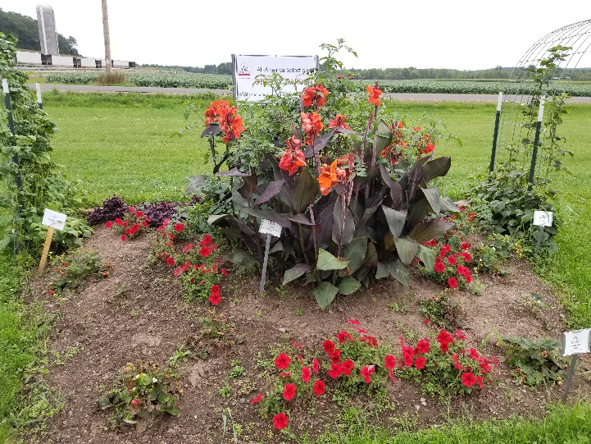
Bed 2:
Bean; Potomac, Seychelles AAS 2017
Pepper; Pretty and Sweet AAS 2015
Strawberry; Delizz AAS 2016
Tomato; Midnight Snack AAS 2017
Alternanthera; Purple Prince
Canna; South Pacific Scarlet AAS 2013
Petunia; Trilogy Red AAS 2015

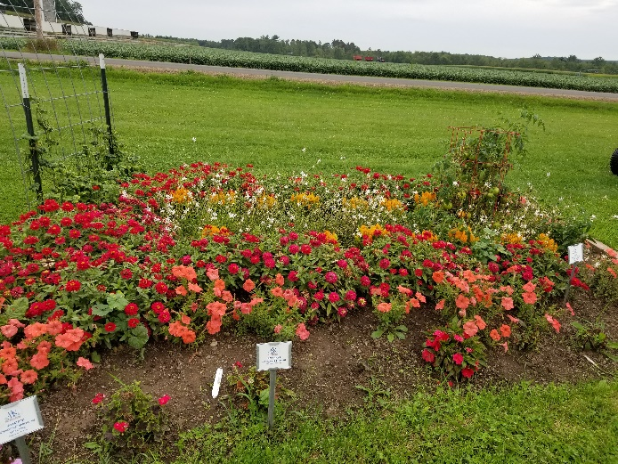
Bed 3:
Bean; Blue Lake
Pepper; Escamillo AAS 2016
Tomato; Chef’s Choice Orange AAS 2014
Celosia; Fresh Look Yellow AAS 2004
Guara; Sparkle White AAS 2014
Geranium; Brocade Cherry Night AAS 2016
Impatiens; Bounce Pink Flame AAS 2015, NG Florific Sweet Orange AAS 2014, Spreading Shell Pink AAS 2015
Petunia; African Sunset AAS 2014
Zinnia; Profusion Double Hot Cherry AAS 2013
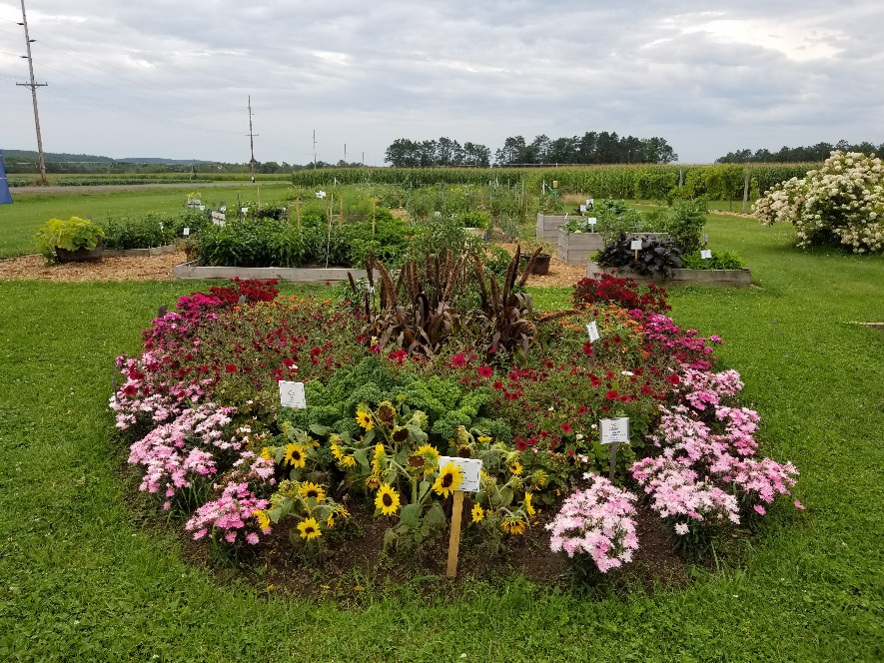
Bed 4:
Kale; Prizm AAS 2016
Pepper; Emerald Fire AAS 2015
Tomato; Black Krim AAS 2017
Dianthus; Jolt Pink AAS 2015, Supra Pink AAS 2017, Rockin Red
Geranium; Pinto Prem. White to Rose AAS 2013
Ornamental Millet
Ornamental Pepper; Black Olive AAS 2012
Petunia; Tidal Wave Red Velour AAS 2015
Sunflower; Suntastic Yellow and Black AAS 2014 Zinnia; Profusion Double Deep Salmon AAS 2013
Bed 5:
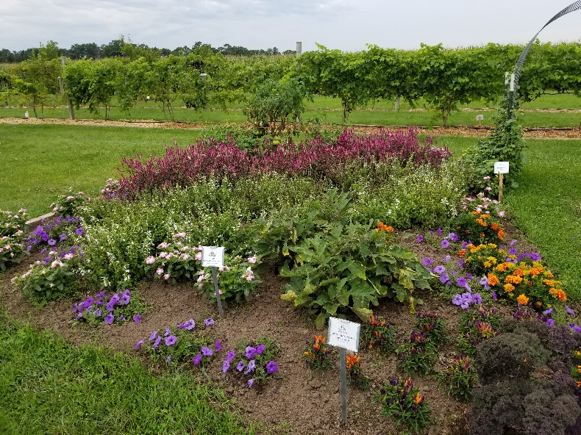
Bean; Kentucky Blue AAS 1991
Eggplant
Kale; Baltic Red
Pepper; Aji Rico AAS 2017
Tomato; Chef’s Choice Pink AAS 2015
Celosia; Asian Garden AAS 2017
Impatiens; Bounce Pink Flame AAS 2015
Orange Marigolds
Ornamental Pepper; Numex Easter AAS 2014
Petunia; Evening Scentsation AAS 2017
Salvia; Summer Jewel White AAS 2015
Vinca; Mega Bloom Orchid Halo AAS 2017

Bed 6:
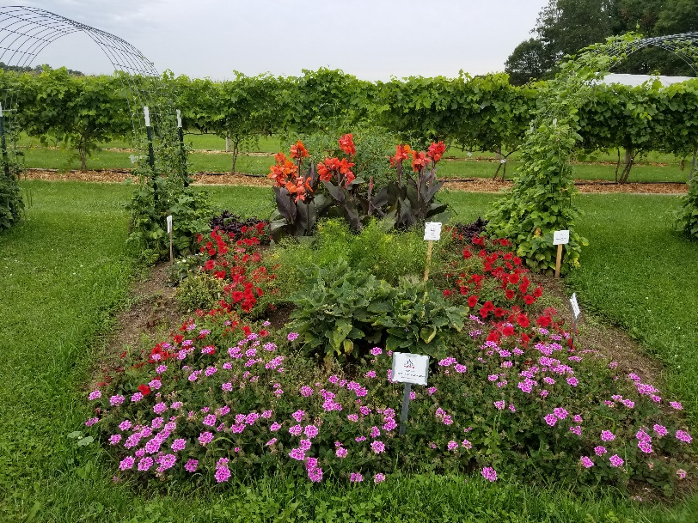
Bean; Kentucky Blue AAS 1991, Rattlesnake
Eggplant
Fennel; Antares AAS 2017
Pepper; Mama Mia Giallo AAS 2014
Strawberry; Delizz AAS 2016
Tomato; Jasper AAS 2013
Alternanthera; Purple Prince
Canna; South Pacific Scarlet AAS 2013
Petunia; Trilogy Red AAS 2015 Verbena; Endurascape Pink Bicolor AAS 2017
Bed 7:
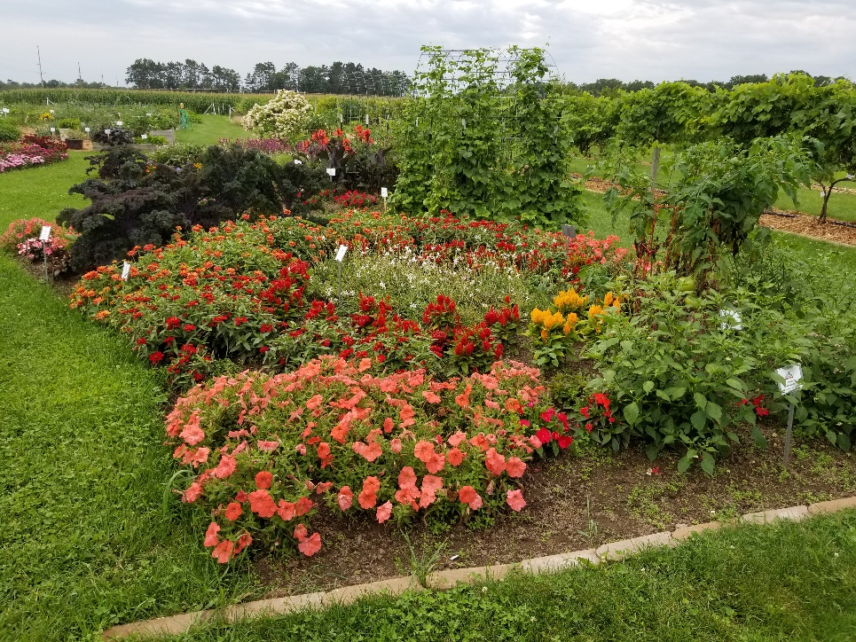
Bean; Rattlesnake
Eggplant
Kale; Baltic Red
Pepper; Mad Hatter AAS 2017
Tomato; Chef’s Choice Orange AAS 2014
Celosia; First Flame Scarlet, Fresh Look Yellow AAS 2004
Guara; Sparkle White AAS 2014
Impatiens; Bounce Pink Flame AAS 2015, NG Florific Sweet Orange AAS 2014, Spreading Shell Pink AAS 2014
Petunia; African Sunset AAS 2014
Zinna; Profusion Double Deep Salmon AAS 2013, Profusion Red AAS 2017
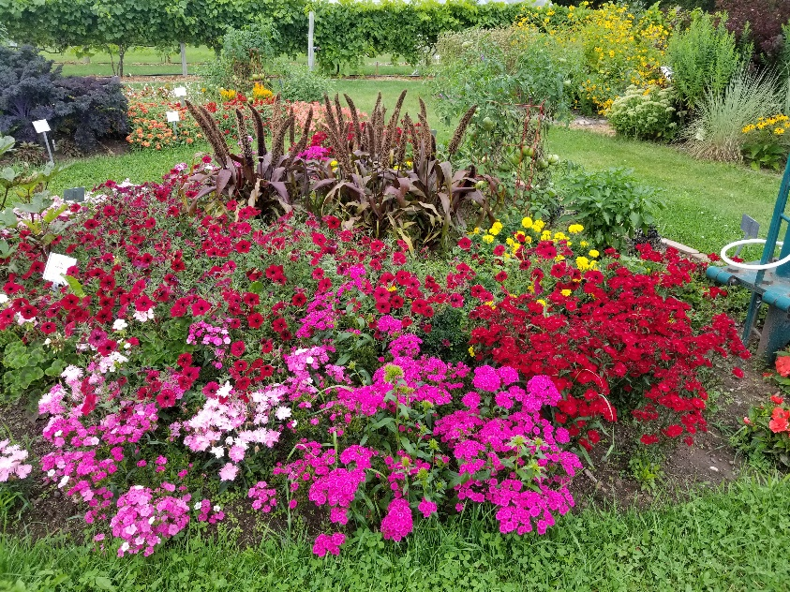
Bed 8:
Basil; Dolce Fresca AAS 2015
Okra; Candle Fire AAS 2017
Pepper; Cornito Giallo AAS 2016
Tomato; Black Krim
Dianthus; Supra Pink AAS 2017, Rockin Red
Geranium; Brocade Fire AAS 2016, Calliope Medium Dark Red AAS 2017, Pinto Prem. White to Rose AAS 2013
Impatiens; Bounce Pink Flame AAS 2015, NG Florific Sweet Orange AAS 2014, Spreading Shell Pink AAS 2015
Yellow Marigolds
Ornamental Millet
Ornamental Pepper; Black Olive AAS 2012
Petunia; Tidal Wave Red Velour AAS 2015
Sunflower; Suntastic Yellow and Black AAS 2014
Vinca; Mega Bloom Orchid Halo AAS 2017, Mega Bloom Pink Halo AAS 2017
12
13
11
7
10
8
9
2
1
4
6
5
3
Container 1
Butterscotch: This adorable small-fruited butternut squash has an exceptionally sweet taste perfect for just one or two servings. Compact vines are space-saving for smaller gardens or those who just want to fit more plants into the space they have. This is another AAS Winners that is perfect for container gardens and will resist powdery mildew later in the season. 85 days from transplanting. AAS 2015
Container 2
Fantastico: Determinate. This is a grape tomato. Reaches harvest in 90 days from seed or 50 days from transplants. This plant is great for hanging baskets, containers, and smaller gardens. Cages are recommended for support. They produce sweet fruits and if let go they resist cracking more than other breeds. This plant is also tolerant to Late Blight. AAS 2014
Container 3
Candyland Red: Indeterminate. This tomato is the only currant that is an AAS Winner. Currant tomatoes are smaller than cherry tomatoes. It takes 95 days from seed to reach harvest or 55 days from transplants. This plant produces dark and sweet tomatoes. AAS 2016
Cornito Giallo: This pepper plant produces mature fruits in 75 days from transplants. This plant produces large yellow fruits that have a fruity flavor. They produce plentiful amounts of fruits that are durable. Great cooked, raw, or fire roasted. AAS 2016
Pretty N Sweet: A unique, compact, colorful, and edible ornamental sweet pepper. It reaches harvest in 105 days from seed or from a transplant in 60 days. They have a mild sweet flavor to them. This plant measures 18” tall and produces more fruit with more flavor than pepper plants like it. AAS 2015
Mama Mia Giallo: A sweet Italian pepper that reaches harvest in 125 days from seed or 85 days from transplants. It produces long golden yellow or orange fruits. They have a nice sweet flavor and are great for grilling, roasting or eating fresh. Tolerant to Tobacco mosaic virus. AAS 2014
Container 4
Fantastico: Determinate. This is a grape tomato. Reaches harvest in 90 days from seed or 50 days from transplants. This plant is great for hanging baskets, containers, and smaller gardens. Cages are recommended for support. They produce sweet fruits and if let go they resist cracking more than other breeds. This plant is also tolerant to Late Blight. AAS 2014
Pretty N Sweet: A unique, compact, colorful, and edible ornamental sweet pepper. It reaches harvest in 105 days from seed or from a transplant in 60 days. They have a mild sweet flavor to them. This plant measures 18” tall and produces more fruit with more flavor than pepper plants like it. AAS 2015
Cornito Giallo: This pepper plant produces mature fruits in 75 days from transplants. This plant produces large yellow fruits that have a fruity flavor. They produce plentiful amounts of fruits that are durable. Great cooked, raw, or fire roasted. AAS 2016
Container 5
Cornito Giallo: This pepper plant produces mature fruits in 75 days from transplants. This plant produces large yellow fruits that have a fruity flavor. They produce plentiful amounts of fruits that are durable. Great cooked, raw, or fire roasted. AAS 2016
Escamillo: This pepper plant grows fruits to full maturity from transplants in 77 days. They produce large golden yellow fruits with a sweet flavor. These pepper plants are compact and early bloomers making them great choices for home gardens. Great raw, cooked, or fire roasted. AAS 2016
Flaming Jade: This is a Serrano variety pepper, packed with heat. These plants reach maturity at 75 days from transplants and 105 days from direct seeding and produce a long green fruit. They are great for large containers and are bred for being disease resistant. This pepper is great for making hot sauces and spicy pico de gallo. AAS 2016
Emerald Fire: This is the hottest pepper in the AAS winners list. This plant reaches harvest at 90 days and produces a large jalapeno fruit. The fruits have a thick skin and have a glossy green look to them. Highly disease resistant. Great for stuffing, grilling, or salsas. AAS 2015
Flaming Flare: This is a Fresno pepper that is a National AAS Winner. They reach harvest after 75 days from transplants. This pepper is sweeter than other Fresno peppers. It will be spicier the later you harvest. Great for chili sauces. AAS 2015
Hot Sunset: A banana pepper that reaches harvest in 85 days from transplants. Early and prolific harvests of deliciously spicy fruits. They produce disease resistant fruits all season long and are great raw, grilled, or roasted. AAS 2015
Pretty N Sweet: A unique, compact, colorful, and edible ornamental sweet pepper. It reaches harvest in 105 days from seed or from a transplant in 60 days. They have a mild sweet flavor to them. This plant measures 18” tall and produces more fruit with more flavor than pepper plants like it. AAS 2015
Mama Mia Giallo: A sweet Italian pepper that reaches harvest in 125 days from seed or 85 days from transplants. It produces long golden yellow or orange fruits. They have a nice sweet flavor and are great for grilling, roasting or eating fresh. Tolerant to Tobacco mosaic virus. AAS 2014
Container 6
Dolce Fresca: If there was an AAS category for an edible plant with ornamental value, this AAS Winner would fit that classification. Dolce Fresca produces sweet tender leaves that outshone the comparison varieties while maintaining an attractive, compact shape that’s both versatile and beautiful. Use the leaves as you would any Genovese basil and we hear it makes an excellent pesto. 60 days from seed. AAS 2015
Antares Fennel: This winner is a “First in Class,” as AAS has never before trialed and declared a fennel an AAS Winner. What is extremely fun about this winning plant is its many uses: as an edible bulb; for its ornamental fronds; as a seed producer; and as a favorite food of pollinators, namely swallowtail caterpillars. 68 days until mature. AAS 2017
Sage
Tyme
Parsley
Peppermint
Container 7
Red Kingdom Mizuna: This is a Japanese mustard. It is both edible and ornamental. It is ready to harvest after 21 to 35 days from seed or 14 days from transplanting. This mizuna has a milder taste to it. AAS 2016
Cornito Giallo: This pepper plant produces mature fruits in 75 days from transplants. This plant produces large yellow fruits that have a fruity flavor. They produce plentiful amounts of fruits that are durable. Great cooked, raw, or fire roasted. AAS 2016
Mama Mia Giallo: A sweet Italian pepper that reaches harvest in 125 days from seed or 85 days from transplants. It produces long golden yellow or orange fruits. They have a nice sweet flavor and are great for grilling, roasting or eating fresh. Tolerant to Tobacco mosaic virus. AAS 2014
Container 8
Pick a Bushel: This Regional AAS Winner is great for northern areas because it is early to set fruit, offers a prolific quantity of fruit and is a compact bush-type cucumber spreading only about 24 inches. Pick a Bushel offers a sweeter tasting light-green cucumber with a nice firm texture, perfect for pickling when harvested early. Fruits left on the bush-type vines longer can get up to 6” long and can be enjoyed fresh in salads. For those gardeners looking for a cucumber that can be grown in patio containers, Pick a Bushel is a great option. 50 days until maturity. AAS 2014
Container 9
Patio Choice Yellow: Determinate. This plant reaches harvest in 65 days from seed or 45 days from transplants. Produces cherry tomatoes. This is a wonderful compact tomato bred to be in urban gardens and containers. It has a high yield sometimes producing up to 100 fruits per plant. Has a sweet taste and are perfect sundried, in the oven, or even fresh. AAS 2017
Container 10
Sandy Lettuce: Ready to harvest from seed in 30 days (baby leaves) and 50 days for full maturity. This lettuce is an oak leaf type. It isn’t bitter when heat stressed typically. It’s resistant to Powdery Mildew, Tip Burn, and Downy Mildew. It’s also heat tolerant. AAS 2015
Pretty N Sweet: A unique, compact, colorful, and edible ornamental sweet pepper. It reaches harvest in 105 days from seed or from a transplant in 60 days. They have a mild sweet flavor to them. This plant measures 18” tall and produces more fruit with more flavor than pepper plants like it. AAS 2015
Container 11
Uluru Orchre: 65 days, tree-type — The vigorous, dwarf, rugose, regular leaf plants are relatively compact, quite early to produce and prolific. Producing a good yield of medium to large sized (six to twelve ounces) oblate uniquely colored tomatoes that are essentially the first "black/orange" variety we've seen - orange flesh with green overtones, and somewhat amber/orange/green in appearance. The flavor can be a bit variable season to season, but at its best, it has an absolutely delicious, smokey flavor.
Sandy Lettuce: Ready to harvest from seed in 30 days (baby leaves) and 50 days for full maturity. This lettuce is an oak leaf type. It isn’t bitter when heat stressed typically. It’s resistant to Powdery Mildew, Tip Burn, and Downy Mildew. It’s also heat tolerant. AAS 2015
Red Kingdom Mizuna: This is a Japanese mustard. It is both edible and ornamental. It is ready to harvest after 21 to 35 days from seed or 14 days from transplanting. This mizuna has a milder taste to it. AAS 2016
Avalanche: A white beet that is ready for harvest in 50 days from seed. It has a sweet taste and is great even when eaten raw. There is no earthy flavor or bitter after taste. AAS 2015
Container 12
Mascotte: Bush bean. This bean reaches harvest in 50 days from seed. This bean is nice and compact which makes it great for containers or smaller gardens. Has very beautiful white flowers. The bean is crunchy and flavorful. Resistant to Bean Mosaic Virus. AAS 2014
Cornito Giallo: This pepper plant produces mature fruits in 75 days from transplants. This plant produces large yellow fruits that have a fruity flavor. They produce plentiful amounts of fruits that are durable. Great cooked, raw, or fire roasted. AAS 2016
Konan Kohlrabi: This kohlrabi is ready to harvest after 50 days from seed or 42 days from transplanting. This variety has been bred for a smoother shape and upright leaves. The upright leaves prevent some insect damage. The bulb has a sweet taste to it. AAS 2016
Container 13
Roxanne: An extremely quick variety that grows to maturity in just 27 days. It’s a hybrid variety. It has a uniform red outside and a clean white inside. No pithiness or bleeding at larger sizes. It also has a great flavor. AAS 2015
Sweet Baby: This radish grows to maturity in 40 to 45 days from seed. It has a purple color to its outside and its inside can range from white with purple streaks in it or purple splashes. These radishes are crunchy, crispy, with a slight spicy flavor. AAS 2016
Red Kingdom Mizuna: This is a Japanese mustard. It is both edible and ornamental. It is ready to harvest after 21 to 35 days from seed or 14 days from transplanting. This mizuna has a milder taste to it. AAS 2016
Fantastico: Determinate. This is a grape tomato. Reaches harvest in 90 days from seed or 50 days from transplants. This plant is great for hanging baskets, containers, and smaller gardens. Cages are recommended for support. They produce sweet fruits and if let go they resist cracking more than other breeds. This plant is also tolerant to Late Blight. AAS 2014
Patio Choice Yellow: Determinate. This plant reaches harvest in 65 days from seed or 45 days from transplants. Produces cherry tomatoes. This is a wonderful compact tomato bred to be in urban gardens and containers. It has a high yield sometimes producing up to 100 fruits per plant. Has a sweet taste and are perfect sundried, in the oven, or even fresh. AAS 2017

Brassica Bed | Pepper Bed | Root Crop Bed
Allium Bed | Heirloom Tomato Bed | Florida Weave Bed

Brassica Bed
Artwork: A broccoli that grows to maturity in 85 days from seed or 55 days from transplanting. This is a stem/baby broccoli variety. It appears to grow normally until the first shoot is cut off. Then all of the side shoots will grow until late in the season. This variety has more resistance to warm weather bolting. AAS 2015
Katarina: A quick cabbage variety, reaching harvest in 55 days from seed or 45 days from transplanting. This is a smaller variety and is able to be planted in containers or in smaller gardens. It has a sweeter and less bitter flavor that other varieties. Smaller heads will develop after the main head is removed. AAS 2016
Prizm: Ready for harvest after 50 to 60 days from seed or 35 to 45 from transplanting. This is a smaller variety of kale making it a great choice for in-ground beds or containers. This plant can also be harvested throughout the year. It has a nutty flavor to its leaves. AAS 2016
Konan: This kohlrabi is ready to harvest after 50 days from seed or 42 days from transplanting. This variety has been bred for a smoother shape and upright leaves. The upright leaves prevent some insect damage. The bulb has a sweet taste to it. AAS 2016
Ruby Red Swiss Chard: Candy-apple red stems with dark-green, red-veined leaves. Great as a true red color in salad mix. NOTE: Young Ruby Red plants may bolt to seed if exposed to frosts; time sowings to avoid frost on seedlings. 59 days.
Pepper Bed
Mad Hatter: From a transplant, this pepper grows to a mature green in 65 to 70 days. It grows to a ripe red in 85 to 90 days. This is a pepper plant that has high yields, vigor, and earliness. It produces a sweet and citrusy flavored fruit that has a unique 3 sided shape to it. These peppers are great for salads or pickling. AAS 2017
Aji Rico: This pepper plant matures extremely quickly. From transplants, the plant can produce green fruits in 50 to 55 days and ripe red in 70 to 75 days. They can be eaten at any stage and have a general citrusy and warm flavor to them. Great for salsa or hot sauce and even homemade paprika. “Aji” means chili in South America. AAS 2017
Aji Delight: A real rarity - full chile pepper flavor without the heat. Extremely vigorous and easy-to-grow. Large 3 to 4 inch bullet shaped red peppers add a new flavor to salads or garnishes - try substituting for bell peppers. Can be used at any color stage. 70-85 days.
Flavorburst: Initial color is lime green, turning to yellow, and then to yellowish orange when ripe. Excellent, sweet flavor. Medium-large bells are mostly 3-lobed and slightly elongated. 87 days.
Procraft: Red or green fruits from organic seed. Widely adapted, Procraft performs well in cool or warm regions. Large, firm fruits are suitable for fresh market but also withstand the rigors of shipping. Flavor is mild, slightly sweet when ripe. High resistance to bacterial leaf spot races 1-3, potato virus Y; intermediate resistance to tobacco etch virus and tomato spotted wilt virus. 85 days for red.
Mega Marconi: This gigantic sweet pepper is a show stopper! Italian-type sweet peppers are 6-8 inches long, 3 inches wide and are blocky shaped with a blunt tip. Fruits have thick walls that ripen to red with a sweet, almost smoky taste. Great raw or cooked – grilling or roasting enhances their incredible flavor. 95 Days.
Root Crop Bed
Rainbow Blend Carrots: Contains Atomic Red, Cosmic Purple, Solar Yellow, Lunar White, and Bambino (orange).
Nantes Carrots: Finely-flavored carrot does well as a bunching carrot and as a storage carrot. It grows 6-8" long and is practically coreless.
Rainbow Blend Beets: Contains Subeto, Boldor, Chioggia, Albina Vereduna, and Bull's Blood Scarletta.
Boldor Beets: Very similar to Touchstone Gold in terms of vigor, performance, and flavor, but Boldor has brighter interior color. Many growers choose one or the other based on personal preference. Keeps its color when cooked. Excellent, sweet flavor. Green leaves and petioles. 55 days until maturity.
Detroit Dark Red Beets: This classic variety produces early, very dark red and extremely sweet roots up to 3" across. Its good fresh, canned or frozen. 59 days until maturity.
Ruby Queen Beets: The Ruby Queen beet is a deliciously dark red beet with a smooth yet rich texture. An "All-America Selections" winner, Ruby Queen produces early and is fabulous canned or pickled. 55 days until mature.
Touchstone Gold Beets: Smooth golden roots with bright yellow flesh retain their color when cooked. Excellent, sweet flavor. Leaves and petioles are green. Very good germination for a golden beet. 55 days until mature.
Allium Bed
Karmen: One of the best open pollinated red onions available. Medium-early and uniform. Dark red skin with good red color through the bulb layers. Known as a good storage type and we have certainly seen this to be true. Medium sweet flavor. 100 days.
Rossa Di Milano: This mid-sized, red Italian onion has a distinctive, mildly hot flavor demanded by chefs for authentic tasting Italian recipes. The large, flat-topped, red-skinned bulbs keep well and tolerate cool climates. Our strain is highly uniform and is best grown in mid-latitude to northern areas. Requires long day length. 115 day.
Red Hawk: Early, long-day, deep red variety. Medium to large, uniform bulbs are slightly flattened with consistent color and excellent skin retention. Adaptable enough to also be grown as a late intermediate-day variety. High resistance to pink root. 107 days.
Prospector (yellow onion)
Dakota Tears: This pungent yellow storage onion produces large bulbs, up to 1 lb. each, with medium thick necks. The bulbs keep well through the winter in the root cellar. A highly uniform, open-pollinated variety that does best in ‘long-day’ northern areas. Requires long day length. 112 days.
Hamilton (yellow onion)
Leek: Onion relative that does require a long season, but is otherwise very easy to grow. Start the tiny seeds indoors in early spring, setting out any time after the hard frosts are gone—seedlings can tolerate a few degrees of frost with no difficulty. 120 days.
Garlic
Heirloom Tomato Bed
San Marzano: An indeterminate plant. This is the classic Italian paste tomato with rich, complex and sweet flavors. This type of tomato is essential for making traditional Napolitano sauces and whole canned tomatoes. The large plants produce loads of small, elongated red tomatoes late in the season and will need to be staked. 80 days to maturity.
Yugo Pink: Also known as the Crnkovic Yugoslavian. Produces vigorous, indeterminate, regular-leaf tomato plants that yield large amounts of extra-large, 1-2 pound, slightly flattened, pink beefsteak tomatoes that are full-flavored, deliciously juicy. A crack-resistant tomato variety. If you can't pronounce the name...the taste will make up for the difficulty. A great tomato for eating fresh in salads or sliced thick for sandwiches. Open pollinated. 80 days to maturity.
Prudens Purple: An indeterminate type heirloom that can produce very large fruits over one pound. Often favorably compared with the illustrious Brandywine, the gold standard of heirloom tomatoes. Fruits are flattened, smooth and resist cracking. This medium tall plant produces fruits that have a vivid dark pink skin with crimson flesh and few seeds. Fruits have a firm, meaty texture.
German Johnson: An indeterminate heirloom which bares 12-24 oz. fruit with smooth tops. They are very productive and resistant to disease. Originally grown in West Virginia, this heirloom was one of the parent lines for another cherished heirloom: the legendary Mortgage Lifter. With pinkish-red skin and nearly seedless meaty, mild flesh, the large, lobed fruits are a favorite variety for both slicing and canning.
Mortgage Lifter: This huge heirloom beefsteak (up to 4 lb.; average 2 1/2 lb.) consistently wins taste-tests. Developed in the 1930s by a gardener who planted the four biggest varieties he knew and crossed one with pollen from the other three. He did this for six seasons and created a variety that produced immense, tasty fruit. He sold the plants for $1 apiece and paid off his $6000 mortgage in 6 years. 80 days until maturity.
Brandywine: Heirloom. This popular beefsteak-sized, Amish tomato produces rosy pink fruits loaded with an old-fashioned tomato taste that has been prized for decades. It is considered one of the benchmarks for intense tomato flavor. The indeterminate vines are vigorous, so use tall cages. Vines yield tomatoes that ripen gradually until frost. Plants have “potato leaf” foliage. The tangy taste of Brandywine is a gourmet cook’s delight. Matures in 80-100 days.
Opalka: Without a doubt, this is one of the best tasting sauce tomatoes you'll find. Flavor is much richer and sweeter than other paste tomatoes, so delicious you can eat them right off the vine. Sauces using the nearly seedless fruits are something special. The bright red elongated 3 to 5 inch fruits are produced in clusters of 2 to 5 on vigorous, high-yielding, indeterminate plants. Fruits hold well on the vine. Matures in 85 days.
Florida Weave
Midnight Snack: Indeterminate. This is an indigo-type cherry tomato. Reaches harvest in 65-70 days from transplants. It produces glossy red fruits with a black or purple when exposed to the sun. This is due to high concentrations of anthocyanins. These are antioxidants. These tomatoes are great for salads or eating straight off the plant. AAS 2017
Candyland Red: Indeterminate. This tomato is the only currant that is an AAS Winner. Currant tomatoes are smaller than cherry tomatoes. It takes 95 days from seed to reach harvest or 55 days from transplants. This plant produces dark and sweet tomatoes. AAS 2016
Chef’s Choice Green: Indeterminate. This plant will reach harvest in 90 days from transplants. This tomato produces green fruits with yellow stripes. They have a citrusy flavor. The plant has been bred to be highly disease resistant. AAS 2016
Chef’s Choice Pink: Indeterminate. This plant will reach harvest in 110 days from transplants. It produces large beefsteak tomatoes. They have a sweet flavor and are great for stewing or canning. Highly disease resistant. AAS 2015
Chef’s Choice Orange: Indeterminate. A rapid growing tomato plant that reaches harvest in 75 days from transplants. This variety is highly disease resistant. It produces sweet orange tomatoes that have a neon inside. They don’t lose their color when cooked. Great for soups and sauces. AAS 2014
Jasper: Indeterminate. A high yielding cherry tomato, which reaches harvest in 90 days from seed or 60 from transplants. Has high weather related stress tolerance. The fruits have a sweet flavor and grow generally uniform. They have a large harvest window. AAS 2013

1
2

3

5
4

Bed 1
Mini Love: This personal-sized Asian watermelon is perfect for smaller families and smaller gardens. Shorter vines (3-4 feet) still produce up to six fruits per plant and can be grown in smaller spaces. Several judges commented on the crack and split resistant rinds, important for reducing crop loss. For culinary purposes, this deep red fleshed watermelon has a thin but strong rind that can be carved into attractive shapes for fruit salad presentations. Mini Love has a high sugar content resulting in sweet and crisp, juicy flesh that will be a true summer delight for watermelon lovers. 70 days from transplanting. AAS 2017
Bed 2
Gold in Gold: The fruit’s outer color is yellow with golden stripes while the inner flesh is a lovely orange/gold. Crisp texture with high sugar contents is also an advantage. This winner is an early producing, high yielding, and improved disease-resistant melon with a strong rind that resists cracking or bursting. The unique oblong shape of the 11-16 pound fruit makes it a perfect “icebox” watermelon and the tasty fruit is superior. 70 days from transplanting. AAS 2017
Bed 3
Mini Love
Gold in Gold
Bossa Nova: This zucchini is ready for harvest in just 30 to 45 days from seed or 25-40 days from transplanting. The zucchini it produces has a decorative outside with light green and dark green molting. This is a more compact plant and will continue producing more than other varieties. They have a sweet mild taste to them. AAS 2015
Wisconsin Lakes: A sweet pepper that is great for short seasons. A good producer of 4-6 oz. fruits. Peppers will turn from green to red when mature. This thick walled pepper is very delicious and sweet.
Purple Beauty: This stunning bell pepper is ready to eat when the fruits turn deep purple with a green undertone. The fruit is thick, succulent, and crisp. This variety is very productive and sets fruit in both the crown and on the limbs. 75 days to maturity.
King Arthur: These widely adapted Plants are large and early to bear big crops of large, thick walled fruits that are sweet and crunchy. Tolerant to most diseases, with High resistance to bacterial leaf spot races. Upright plants reach about 22" in height baring fruits that are about 4-1/2" by 4-1/2",

King of the North: This reliable variety produces sweet, blocky and uniform fruits which are excellent for stuffing or fresh eating. Perfect for northern gardeners where season are cool and short. Plant is 24” – 36” tall and fruits are 4”-6” long. 70 days to maturity.
Ruby King: Claimed to be one of the best peppers of all times! This Heirloom is a super sturdy 24” plant that supports heavy crops of blocky, 4 lobed peppers that ripen from green to red. It has a candy like, mild, sweet flavor. Ready to pick in 70-75 days.
Giant Marzoni: A 2001 AAS winner. This hybrid plant produces large, tapered, elongated fruits that grow up to 8” long and 3” wide at the upper end. Fruits are sweet, yet smoky and are equally delectable whether eaten green or red, fresh or grilled. Great, reliable yields. 72 days to maturity.
Healthy: A gardener couldn’t ask for more in a pepper. Healthy produces heavy yields of appealing, sweet, disease-resistant fruit even in cloudy, cooler growing season. The fruit is blocky and measure 2” across and 5” long. They ripen from yellow to orange and finally red. A dependable producer of delicious fruit. 70-75 days to maturity.
New Ace: Huge yields of medium sized 3-4 lobed fruits. This variety seems to have a tolerance to blossom drop as nearly every flower produces a pepper. Widely adapted but performs particularly well in cool climates where bell peppers are difficult to grow successfully. F1 hybrid. 62 days to maturity.
Bed 4
Cherokee Purple: An indeterminate heirloom. The plant bares 12-16oz attractive dark pink-purple fruits that have an excellent complex flavor. These have a slightly sweet aftertaste and are perfect for slicing. Its flavor is rich and full—often compared with Brandywine. This large tomato from Tennessee is rumored to have come from Cherokee gardeners.
Russian Persimmon: An indeterminate, beefsteak type. This is a very attractive yellowish-orange tomato originally from Russia. The flavor is outstanding, with significantly more acid than in most yellow tomatoes. These short plants are less than 4 ft. tall, but bear an abundance of these striking tomatoes that can weigh up to 1 lb. Performs well in short-season areas.
Stupice: A great indeterminate, potato leaf variety that comes from Czechoslovakia. This variety is among the earliest producers and has an excellent flavor for an early type. The fruit is considered to be rich and tangy. It is perfect for gardeners in northern climates with short summers. These produce lots of red, small to medium sized fruit over a very long season.
Black Krim: This variety hails from the Black Sea, near the Crimean Peninsula of Russia, where warm influences from the Black Sea make summers perfect for growing tomatoes. Heat-tolerant Black Krim has a dark brown-red color that gets even darker in hotter weather. Always a favorite in taste tests, Black Krim has a flavor that is described as tangy, rich, and sweet. It makes beautiful dark slices. Black Krim is prone to cracking, so be sure to water regularly, especially when there is not enough rain, to avoid cycles of wet-to-dry-to-wet-to-dry soil that causes the fruit to crack.Vigorous plants grow best with strong staking or tall cages.
Sun Gold: This treat of a tomato is one of the garden’s sweetest. Children will eat them like candy. Sun Gold ripens in long clusters of 10 to 15 fruits. The sweet flavor is ready about a week before full coloring. Wait to pick fruits at their deepest hue and you’ll experience a richly sweet, fruity flavor. Eat fruits as a healthy snack, add to green salads, or mix into fruit salad. The indeterminate vines are resistant to many diseases: verticillium wilt (V), fusarium (F), and tobacco mosaic virus (TMV). Matures in 55-65 days.
Juliet: Slightly larger than the well-known Santa grape tomato, Juliet bears delicious, sweet fruit on indeterminate vines. Some gardeners refer to it as a mini Roma because of the shape. The wonderfully sweet fruit are crack resistant and remain in good condition on the vine longer than most cherry tomatoes. The fruit are as soft and juicy as cherry tomatoes, they hold up well in salads, even leftovers, and they have a longer shelf life so you can keep them on hand without picking every day. The vigorous vines set lots of fruit on long trusses and keep setting fruit throughout the summer. Quite heat and blight tolerant. Vines are long and vigorous, so give the plant room to tumble over its cage. One of the longest-lasting tomatoes in the garden. Hybrid. Matures in 60 days.
Big Beef: For years gardeners wanted a large, beefsteak-type tomato that was delicious, early to bear, and highly disease resistant. Finally in 1994 those wishes came true with Big Beef. The large fruit has old-time tomato flavor and the vines are resistant to many of the problems that can discourage gardeners. The fruit is borne on vigorous, indeterminate vines from summer until frost. Compared to other beefsteak types, Big Beef is early and will set fruit reliably even in cool, wet weather. Resistant to verticillium wilt (V), fusarium wilt (F) races 1 and 2, nematodes (N), and alternaria stem canker (ASC), gray leaf spot (St), and tobacco mosaic virus (TMV). 73 days until mature.
Bed 5
Insectary: The idea of an insectary is that certain plants contain properties that either invite beneficial insects or repel harmful insects. Beneficial insects prey on pests that cause damage in the garden. Ladybugs and praying mantis are good examples of beneficials. Using plants for pest control not only cuts down on your workload, but it also reduces the amount of insecticides that you use in your garden. And fewer insecticides means more good bugs, which in turn means help in controlling bad bugs.

Lemon Balm: Lemon balm is valued as a culinary, cosmetic and medicinal herb. Use fresh sprigs to top drinks and as garnishes on salads and main dishes. The fresh or dried leaves make a great cold or hot tea, and the dried leaves can be used pot-pourris. Traditionally valued as a medicinal herb, lemon balm has mild sedative properties. Lemon balm is easy to grow from seed sown in the spring or early fall.
White Alyssum: This fragrant garden favorite produces masses of crisp white blooms Perfect choice for lining walkways or in window boxes. This annual attracts Hoverflies, Lacewings and Tachnid flies. Alyssum is deer resistant and tolerates partial shade.
Fennel: Use fresh fennel leaves in salads or with eggs, fish and sauces.
Full Description
The bulbous stem can be steamed, grilled or served raw; it's like celery with a delicate anise aroma. It has many medicinal properties. Likes full sun and mild to cool weather. Start outside after danger of frost.
Dill: Dill attracts hoverflies and predatory wasps (good guys), and swallowtail butterfly caterpillars use its foliage as food. Tomato hornworms are also attracted to dill, so if you plant it at a distance, you can help draw these destructive insects away from your tomatoes. Dill repels aphids and spider mites. Try sprinkling dill leaves on your squash plant to repel squash bugs. But be forewarned: Dill re-seeds with a vengeance and takes over the garden in a hurry, so you need to cut the seed heads before they ripen.
Parsley: A high-yielding, very large and vigorous herb. This herb's dark green leaves have a beautiful, ferny appearance, and they grow in mounded clumps that look especially attractive along a border. Parsley leaves are rich in vitamins and minerals.
Cosmos: Excellent eye-catching border plant, and in pots and bouquets. Cosmos require little fertility or care, making them great for beginner gardeners. Attracts Hoverflies, Parasitic Wasps and Lacewings. Cosmos are great source of nectar and pollen for beneficial insects.
Borage: This plant is a real workhorse in the garden. It repels tomato hornworms and cabbage worms and attracts beneficial bees and wasps. Borage also adds trace elements to the soil. This is an annual, but readily comes back each year from seed.
Sunflower: Attracts beneficial Pirate Bugs, Aphidius and Parasitic Wasps. Use sunflowers as a way to draw aphids away from other plants. Ants will move their colonies on to sunflowers. The sunflowers are tough enough that they suffer no damage. However, if you have friendly neighborhood deer, they find sunflower sprouts quite tasty.

Achillea: An all-time favorite for the sunny border. Tall, flat clusters of delicate flowers are outstanding as dried cuts, with stiff stems and persistent color. Start indoors 8 weeks before last frost. Achillea is tolerant to drought and butterfly friendly. Attracts beneficial insects like Lacewings, Aphidius and Ladybugs
Lemon Verbena: A plant for every garden space. Give this herb soil with good drainage and watch it take off. Lemon Verbena has a delightful lemon fragrance. This is an easy, low maintenance plant. Does well in containers.
Squash and Pumpkin Patch 1
Squash and Pumpkin Patch 2

Patch 1
Butterscotch: This adorable small-fruited butternut squash has an exceptionally sweet taste perfect for just one or two servings. Compact vines are space-saving for smaller gardens or those who just want to fit more plants into the space they have. This is another AAS Winners that is perfect for container gardens and will resist powdery mildew later in the season. 85 days from transplanting. AAS 2015
Waltham Butternut Squash: Heirloom. This variety, Waltham Butternut, has a hard, yellow to tan exterior but delicious sweet, orange flesh inside. Exceptional quality, no stringiness. This long-lasting squash stores all winter. Try it steamed, boiled or baked. Extremely rich in vitamin A. This is the most common winter squash used to make the popular, creamy soup by the same name, and it is a popular baking squash. Matures in 82 days.
Sunshine Squash: This unique red Kabocha-type winter squash will be easily recognized by its bright red-orange skin color, but will be sought-after for the delicious sweet, nutty flavor of its thick, creamy-smooth and stringless bright orange flesh that's rich in vitamins. Space-saving 6 to 8 foot vines yield a good supply of flattened, globe-shaped, 3 to 4 pound fruits. Early maturity makes it adaptable to almost any growing location in North America. Matures in 95 days. AAS 2004
Burgess Buttercup Squash: One of the highest quality squashes sold in the Northeast. Extra rich and sweet in flavor, the deep orange flesh is firm and smooth. The blocky 6 to 8" wide x 3-1/2 to 4" long dark green fruit have a small gray button at the blossom end and grow on a full vine. Matures in 100 days.
Hijinks: Is defined as lively enjoyment and unrestrained fun is an apt name for this AAS pumpkin winner that offers loads of seasonal fun for kids. This winning pumpkin variety produces small-sized, 7 to 9-pound fruits, of a very uniform size and shape. Smooth deep orange skin with distinctive grooves gives a very classy appearance to fall decorations and is ideal for painting or carving. The strong durable stem makes a great handle. Gardeners can expect high yields, notable resistance to powdery mildew, easy fruit removal from plants and excellent stem attachment. Allow plenty of space in the garden for long vines that spread up to 15 feet. Early to mature, this Cucurbita pepo is ready for harvest in about 100 days from sowing or 85 days from transplant. AAS 2011
Pepitas: The newest All-America Selections award-winning pumpkin, Pepitas, is a winner in both the decorative and culinary arenas. Pepitas is named for its hulless or naked seeds (pepitas) that lack the tough outer hull making them easy to eat after slow-roasting. Pepitas are a delicious and nutritious treat, with many health benefits! Each high yield plant produces numerous, uniform medium sized (9 – 12 pounds) pumpkins on healthy, disease resistant vines. This confectionery type of pumpkin produces beautiful orange fruits that at maturity have decorative green stripes. What an interesting change of pace for your fall decorations. 90 days until maturity. AAS 2016
Patch 2
Supermoon: Love the look of white pumpkins for your fall holiday décor? Then you will love our first-ever white pumpkin AAS Regional Winner Super Moon F1. Our judges loved the nice, eye-appealing ghostly white coloration on the large, blemish-free round pumpkins. Grown for their size, up to 50 pounds, and their clean white color, these hardy plants are known for their early fruit development and vigorous growth. Their stems are tough, hardy, disease-resistant and unstoppable! When done decorating with these beauties, consider trying the yellow flesh for roasting or in your fall harvest soups. 90 days until mature. AAS 2016
Cinderellas Carriage: Cinderella’s Carriage is a dream come true for any princess-loving child who wants to grow their own fairy tale type pumpkin. This bright reddish-orange pumpkin is the first hybrid Cinderella-type pumpkin on the market which results in a higher yield as well as Powdery Mildew resistance in the garden. Robust and vigorous vines produce large fruits ranging from 25-35 pounds, creating a whole grouping of carriages for all the princesses in your family. Magical pink-red colored fruit shaped like the pumpkin carriage from the fairy tale Cinderella. Some lucky gardeners could also experience a pale blue pumpkin. Large trailing vine sets up to 5-7 fruit per plant. Well suited for fall decorations and baking. Flesh is yellow, sweet and has a nutty flavor. 100 days. AAS 2014

Chiogga: This heirloom sea pumpkin is named for the fishing village Chioggia, which is situated on the coasts of Italy. The large turban shaped fruit are deep blue-green. It is one of the most beautiful and unique of all squash. A perfect variety for market gardeners. The rich, sweet flesh is a deep yellow-orange and of good quality, delicious baked or in pies. The fruit weigh about 10 lbs. each and are produced on vigorous vines. Stunning! 95 days to maturity.
Long Island Cheese Pumpkin: Medium-large, flattened, medium-ribbed, suggesting a wheel of cheese. Smooth, tan skin, slender woody stem. Deep orange, moderately sweet flesh for pie. Long storage. A beautiful oldie.
Stella Blue Pumpkin: It has sweet, richly flavored, fiberless flesh, delicious, dry, and almost flaky. Medium-sized, round, slightly flattened, blue fruits store well. Planting depth: 1 inch. Days to germination: 3-7 days. 95-105 days to maturity.
Wisconsin Bed | 3 Sisters Bed | Cucurbits Bed | Pumpkin/Squash Patch
Melon Bed | Kale Bed | Legume Bed | Weed Patch

Wisconsin Bed
Badger Flame: Flame is a new open pollinated cultivar from the university of Wisconsin-Madison table beet breeding program. Flame has a red and yellow interior and is oblong in shape. Foliage is light green. Petioles are yellow. Just below the skin, the beet has an orange pigmentation.
Badger Torch: Torch is a new open pollinated cultivar from the university of Wisconsin-Madison table beet breeding program. Torch has a red and yellow interior and is oblong in shape. Foliage is light green. Petioles are yellow. Just below the skin, the beet has an orange pigmentation.
Wisconsin Woasta: When picked green this mild chili pepper is ideal for roasting and stuffing. It is an early maturing derivative of poblano peppers that have round shoulders. Grows up to 24 inches, may need staking. This hybrid (pasilla x poblano) was bred and developed specifically for Wisconsin growing conditions by Jim Nienhuis, UW-Madison Horticulture Professor and chile relleno connoisseur.
Aji 26
Aji Sweet Cayenne Skinny
Aji Sweet Cayenne Medium
Aji Sweet Cayenne Large
Three Sisters Bed: According to Iroquois legend, corn, beans, and squash are three inseparable sisters who only grow and thrive together. This tradition of interplanting corn, beans and squash in the same mounds, widespread among Native American farming societies, is a sophisticated, sustainable system that provided long-term soil fertility and a healthy diet to generations.
As older sisters often do, the corn offers the beans needed support. The beans, the giving sister, pull nitrogen from the air and bring it to the soil for the benefit of all three. As the beans grow through the tangle of squash vines and wind their way up the cornstalks into the sunlight, they hold the sisters close together. The large leaves of the sprawling squash protect the threesome by creating living mulch that shades the soil, keeping it cool and moist and preventing weeds. The prickly squash leaves also keep away raccoons, which don’t like to step on them.
Gete Okosomin: An old variety of winter squash that was traditionally grown by Native Americans. These heirloom seeds have been cultivated, saved and passed down for thousands of years. This prolific plant can produce extensive vines and very large squash up to 30 lbs. The fruit has abundant flesh and good flavor. A delicious variety.

Cherokee Trail of Tears Beans: A vigorous, prolific and vining plant. This heirloom pole bean is perfect for dry beans, fresh eating, canning and freezing. The Cherokee people brought this bean along with them as they were forcibly marched from Tennessee to Oklahoma. This variety will grow well in most regions of the United States. Has 6” long bean pods filled with jet black beans. 65 days to maturity.
Oaxacan Green Dent Corn: Grown for centuries by the Zapotec Indians of Southern Mexico where it is used to make green flour tamales. Traditionally grown with squash and beans. Drought resistant, sturdy, 7’ plants produce iridescent green kernels on 10” ears. 75-100 days.
Cucurbit Bed
Yellow Crookneck Squash: Heirloom. Easy to grow and fast to mature. This is a summer squash, bearing many lemon-yellow, 6-inch fruit, with a slightly bent neck that earns it the name Crookneck. Plants are fast growing and very prolific. Harvest all summer long. Delicious steamed with nutmeg or fried in slices and sprinkled with parmesan cheese and crumbled bacon. Harvest while skins are soft. Keep plants picked so they keep producing. Reaches maturity in 53 days.
Dark Green Zucchini: Matures in 50 days — The bush-type plants are vigorous and produce early. The fruits are straight, smooth, mottled dark green. The flesh has a pale green tint to it, is firm and has a fine flavor. We find it best to keep picked at six to eight inches.
Yamato Sanjaku Cucumber: Sanjaku means three feet. This cucumber variety produces a generous crop of remarkably long, narrow fruit. It is best if harvested up to 2 feet long with a 2" diameter. The fruits have white flesh, relatively small seed cavity, and sweet flavor. It has a monecious flowering habit (plant produces both male and female flowers) and moderate resistance to both downy and powdery mildew. Matures in 50-75 days.
Homemade Pickles Cucumber: 55 days. Especially bred for home pickling, these attractive, extra-tasty cukes will make perfect pickles every time! Boasting solid, crisp flesh and excellent bite, they should be harvested at about 1 1/2 inches for tiny sweet pickles, or let mature to 5 or 6 inches for hefty, robust dills and spears. At whatever size, they are firm and tender-sweet! Plants grow very vigorously over a long season, with great disease resistance for even bigger yields. Support the bountiful vines with a trellis or staking.
Bossa Nova: This zucchini is ready for harvest in just 30 to 45 days from seed or 25-40 days from transplanting. The zucchini it produces has a decorative outside with light green and dark green molting. This is a more compact plant and will continue producing more than other varieties. They have a sweet mild taste to them. AAS 2015
Pick a Bushel: This Regional AAS Winner is great for northern areas because it is early to set fruit, offers a prolific quantity of fruit and is a compact bush-type cucumber spreading only about 24 inches. Pick a Bushel offers a sweeter tasting light-green cucumber with a nice firm texture, perfect for pickling when harvested early. Fruits left on the bush-type vines longer can get up to 6” long and can be enjoyed fresh in salads. For those gardeners looking for a cucumber that can be grown in patio containers, Pick a Bushel is a great option. 50 days until maturity. AAS 2014
Pumpkin/Squash Patch
Cotton Candy Pumpkin: Unique all-white pumpkin. Even the flesh of this pumpkin is white, though it is not a prime variety for use in cooking. The fruits are nearly round, measuring about 9 inches and weighing 5 to 12 pounds each. Their smooth, glossy skin makes them excellent for painting and they have strong sturdy handles. Harvest when white and store in the dark to maintain the best white color. Full-size vines are very productive. 100 days
Queensland Blue: Not your average Halloween Jack-o-Lantern! Striking blue, flattened, highly ribbed pumpkins that average 10-20 lbs. each. The flesh of Queensland Blue is golden and very sweet, with a flavor that lasts for months in storage. Queensland Blue pumpkin seeds are an old Australian heirloom that came to America in 1932. It has all the keeping power of a Hubbard squash. Let the fruits mature fully on the vine until the foliage begins to die back. Then wipe the outside of each fruit with a weak solution of bleach in water. This will kill off any bacteria and promote good storage. Be sure to use any nicked or cut fruits right away, as they will not have the same storage potential. 110 days.

Melon Bed
Faerie: It is a non-traditional watermelon in that it has a creamy yellow rind with thin stripes yet still yields sweet pink-red flesh with a high sugar content and crisp texture. Home gardeners will like growing something unique in their garden and the fact that the vines are vigorous yet spread only to 11 feet means it takes up less space in the garden. Each 7-8 inches fruit weighs only four to six pounds making it a perfect family size melon. Professional growers will appreciate the disease and insect tolerance as well as the prolific fruit set that starts early and continues throughout the season. 60 days from transplanting. AAS 2012
Melemon: The earliness, high yield on healthy, strong plants and superior taste all contributed to this melon becoming an AAS Winner. Judges related the taste of this melon to honeydew, but with a surprising and delicious tanginess. A uniform fruit shape makes it perfect for market growers as well as home gardeners. Each personal-sized fruit has refreshing crisp flesh and a unique sweet-tart taste. 70 to 80 days to maturity, from transplanting. AAS 2013
Kale Bed
Baltic Red: An heirloom variety originating in the Baltic states (Estonia, Latvia, and Lithuania). The whole plant is deep purple red. Sturdy 2′ tall plants have medium-sized finely curled leaves. Yields are good and the plant is very hardy. Mild flavor, leaves turn dark green when cooked. It’s really quite gorgeous and a great choice for an edible ornamental. Matures in 65 days.
Scarlet: The broad, frilly, purple leaves grow on 2-3' tall, upright stalks. Scarlet compares to Redbor in height, leaf shape, and color. Good uniformity for an open-pollinated variety. Great for baby leaf and bunching. Matures in 55 days.
Olympic Red: Color is variable, ranging from dark reddish-green with purple ribs to full-purple. Tightly curled leaves with long petioles make colorful bunches. Uniform size, shape, and yield with excellent vigor and cold hardiness. Sustained harvest from the lower leaves up, like Winterbor. 60 days until mature.
Nash’s Green: Stout, strong plants packed with curly leaves. Sweeter and more tender than Ripbor, with more variability in height. Produces late into the season with minimal leaf yellowing; ideal for overwintering from June plantings. Good resistance to powdery mildew in the damp winters of the Northwest. Bred by farmer-breeder Nash Huber of Nash's Organic Produce in Washington State, with support from Organic Seed Alliance. Matures in 55 days.
Meadowlark: Exceptionally attractive plants with tall, upright architecture and narrow, tightly curled leaves that are sweet, tender and easy to de-rib. So pretty it could pass as an ornamental! A German specialty with impressive frost-tolerance. Not as curly at the baby leaf stage. Matures in 50 days.
Darkibor: Early maturing, easy growing kale for late summer and fall harvest. Upright plants, finely curled leaves. Good field holding ability.
Curly Roja: Densely frilled leaf edges, stunning purple sage color, deep purple stems and cold hardiness are all element of an exquisite kale bunch that holds well after harvest. Does especially well under fertile conditions.
Legume Bed
Jacob’s Cattle Bean: An heirloom variety also known as 'Trout Bean', these kidney-shaped white beans are liberally splashed with maroon. Favored for baked bean recipes as they soak up flavors readily while retaining their own identity. Matures in 85-90 days.
Cherokee Wax Bean: Developed at Clemson University. Stringless even when mature. Unlike most bean varieties, Cherokee Wax stays tender when frozen, also good canned or fresh. Has attractive purple blossoms and yellow pods. Tender, slightly nutty flavor. 51 days until mature.
Royal Burgundy Bean: The Royal Burgundy bean is absolutely delicious! This purple bean plant grows upright, 24 inch tall plants hold their pencil-shaped pods off the ground. Royal Burgundy performs exceptionally well under cool conditions. Rich, delicious bean flavor. Mature in 60 days.
Streamline Runner Bean: Amazingly prolific, produces clusters of tender, straight pods suitable to be used as snaps. Pods can reach 18 inches in length and are fine for freezing. Seeds can also be used as shell beans or when dried.
Oregon Sugar Pod II Pea: As versatile as snap peas-pick snow peas flat and tender. Vigorous 28" plants bear 4 1/2" long pods. Resistant to pea virus, common wilt and powdery mildew. Superb for freezing. Direct-sow in early spring, again in midsummer for a fall crop. Outstanding winter crop in Zones 9-11. Matures in 68 days.
Tongue of Fire Bean: A market standout with striking red-streaked pods. The fresh shell beans are large and round. The 6-7" stringless pods can be eaten and marketed young as snap beans. These Italian beans retain their flavor whether fresh, frozen, or canned. Original stock seeds collected at the southern tip of South America, in Tierra del Fuego. Also of superior quality as a dry bean. Mature in 70 days.

